OWASP JUICE SHOP
PENETRATION TEST REPORT
Web Application Penetration Test Report
Assessment Type: Black-Box Web Application Penetration Test
Prepared For: Portfolio / Security Assessment Laboratory

Prepared By: Harrison Okechukwu
Date: July 2026

Table of Contents
Table of Contents 1
1. Executive Summary 1
Overview 1
Assessment Summary 1
Overall Risk Rating 1
2. Engagement Overview 1
2.1 Objective 1
2.2 Scope 1
2.3 Rules of Engagement 1
2.4 Assumptions 1
2.5 Limitations 1
3. Testing Methodology 1
4. Testing Environment 1
4.1 Assessment Environment 1
4.2 Tools Used 1
5. Findings 1
Finding 1 – Broken Access Control (User Enumeration) 1
Finding 2 – Insecure Direct Object Reference (IDOR) 1
Finding 3 – Unauthorized Basket Modification 1
Finding 4 – Unauthorized Basket Deletion (IDOR) 1
Finding 5 – Information Disclosure via API 1
Finding 6 – Administrative Interface Discovery 1
Finding 7 – Authentication & JWT Assessment 1
Finding 8 – SQL Injection Authentication Bypass 1
Finding 9 – Stored Cross-Site Scripting (Stored XSS) 1
6. Validation / Retest Summary 1
Overall Impact 1
7. Risk Summary 1
8. Recommendations 1
8.1 Implement Server-Side Authorization 1
8.2 Enforce Role-Based Access Control (RBAC) 1
8.3 Prevent Information Disclosure 1
8.4 Strengthen Object-Level Authorization 1
8.5 Improve Logging and Monitoring 1
8.6 Conduct Regular Security Testing 1
9. Conclusion 1
10. References 1
11. Appendices 1
Appendix A – Testing Methodology 1
Appendix B – Tools Used 1
Appendix C – Evidence Index 1

1. Executive Summary

Overview
A security assessment was conducted against the OWASP Juice Shop web application to evaluate its resilience against common web application attacks. The assessment followed a structured penetration testing methodology, beginning with reconnaissance and enumeration before progressing through vulnerability assessment, exploitation, authorization testing, and validation of identified findings.
The assessment focused on identifying vulnerabilities related to authentication, authorization, access control, information disclosure, and insecure application functionality.
The assessment identified nine security findings: two Critical, five High, one Medium, and one Informational finding. The most significant vulnerabilities identified were SQL Injection leading to administrator authentication bypass, an IDOR allowing unauthorized deletion of another user's shopping basket, further Broken Access Control issues (user enumeration and basket modification), Information Disclosure via exposed API endpoints, and Stored Cross-Site Scripting (XSS).
These findings demonstrate how insufficient authorization checks can allow authenticated users to access or manipulate resources belonging to other users, highlighting the importance of implementing server-side authorization controls and least-privilege access.
No destructive testing was performed beyond what was necessary to validate identified vulnerabilities.

Assessment Summary
Category | Result
Reconnaissance | Completed
Enumeration | Completed
Authentication Testing | Completed
Authorization Testing | Completed
Input Validation Testing | Completed
Information Disclosure Testing | Completed
Business Logic Testing | Completed
Reporting | Completed

Overall Risk Rating
Overall Risk: CRITICAL
The application exposed multiple authorization weaknesses — including a confirmed SQL Injection authentication bypass and an IDOR permitting deletion of another user's data — that could allow authenticated or unauthenticated users to access information or perform actions beyond their intended privileges. If present in a production environment, these issues could lead to unauthorized data access, privacy violations, and compromise of business integrity.

2. Engagement Overview

2.1 Objective
The objective of this engagement was to assess the security posture of the OWASP Juice Shop web application by identifying vulnerabilities that could compromise the confidentiality, integrity, or availability of the application and its data.
The assessment aimed to evaluate the effectiveness of the application's authentication and authorization mechanisms, identify insecure configurations, test for common web application vulnerabilities, and validate whether proper access controls were enforced across exposed API endpoints.

2.2 Scope
The assessment was limited to the locally hosted OWASP Juice Shop application running on:
Item | Details
Target | OWASP Juice Shop
Host | Localhost
Port | 3000
Application Type | Single Page Web Application (SPA)
Assessment Type | Black-Box Web Application Penetration Test

The assessment included publicly accessible pages, authenticated user functionality, exposed REST API endpoints, and administrative functionality where reachable through testing.

2.3 Rules of Engagement
The following rules governed the assessment:
- Testing was performed only against the local OWASP Juice Shop instance
- No attacks were conducted against third-party systems
- Exploitation was limited to proof-of-concept validation
- No intentional denial-of-service (DoS) attacks were performed
- Testing focused on identifying and validating vulnerabilities without causing unnecessary disruption to the application

2.4 Assumptions
- The application was intentionally vulnerable for educational purposes
- The testing environment accurately represented the deployed application
- Tester accounts were permitted for authenticated testing
- The assessment was conducted from the perspective of both unauthenticated and authenticated users

2.5 Limitations
- Source code was not available for review
- Infrastructure components (operating system, web server, database server, and network devices) were outside the scope of testing
- Mobile application testing was not included
- The assessment focused solely on the web application and exposed API endpoints

3. Testing Methodology
The assessment followed the Penetration Testing Execution Standard (PTES), a structured methodology that provides a systematic approach to penetration testing from planning through reporting. The phases completed during this engagement were:

Phase 1 – Reconnaissance
Information gathering was conducted to identify exposed functionality, application structure, directories, technologies, and available endpoints. Both passive and active techniques were used to understand the application's attack surface.

Phase 2 – Enumeration
Application features and API endpoints were enumerated using browser analysis, Burp Suite, Gobuster, Nikto, and manual exploration. Authentication mechanisms, user functionality, and administrative interfaces were identified.

Phase 3 – Vulnerability Assessment
Discovered functionality was assessed for common web application vulnerabilities, including authentication weaknesses, authorization flaws, information disclosure, insecure direct object references (IDOR), input validation issues, and business logic weaknesses.

Phase 4 – Exploitation
Validated vulnerabilities were safely exploited to confirm their impact. Testing focused on demonstrating unauthorized access and manipulation of resources without causing damage to the application.

Phase 5 – Post-Exploitation Validation
The identified vulnerabilities were reviewed to determine their potential impact on confidentiality, integrity, and access control. Evidence was collected to support each confirmed finding.

Phase 6 – Reporting
All confirmed findings, supporting evidence, risk ratings, and remediation recommendations were documented in this report.

4. Testing Environment

4.1 Assessment Environment
The penetration test was conducted against a locally hosted instance of the OWASP Juice Shop application in a controlled laboratory environment. This ensured that all testing activities could be performed safely without affecting production systems.
Component | Details
Target Application | OWASP Juice Shop
Deployment | Localhost
URL | http://localhost:3000
Operating System | Kali Linux
Testing Approach | Black-Box Assessment
Authentication | Authenticated & Unauthenticated Testing

4.2 Tools Used
Tool | Purpose
Burp Suite Community | Intercepting and modifying HTTP requests
Firefox Browser | Manual testing
Nmap | Port scanning and service discovery
Gobuster | Content and directory enumeration
Nikto | Web server assessment
Browser Developer Tools | JavaScript and request analysis
JWT Decoder | JWT inspection and analysis
Linux Terminal | Manual HTTP requests and enumeration

5. Findings

Finding 1 – Broken Access Control (User Enumeration)
Severity: High
CVSS v3.1: 7.5 (High)
OWASP Top 10: A01:2021 – Broken Access Control
CWE: CWE-284 – Improper Access Control

Description
During authorization testing, the endpoint GET /api/Users was accessed using a standard authenticated customer account. Instead of returning information related only to the authenticated user, the application disclosed the complete list of registered users, including administrative and customer accounts.

Affected Component / Endpoint
GET /api/Users

Evidence
Figure 1 — Request
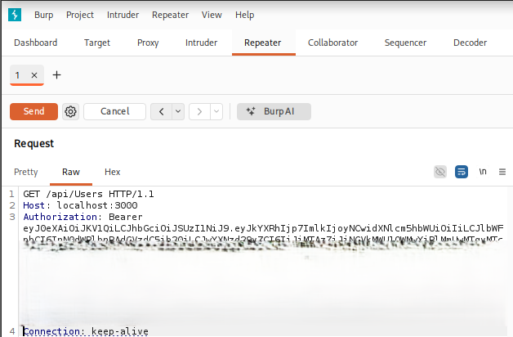
Figure 1 — Response (user records, including administrator accounts)
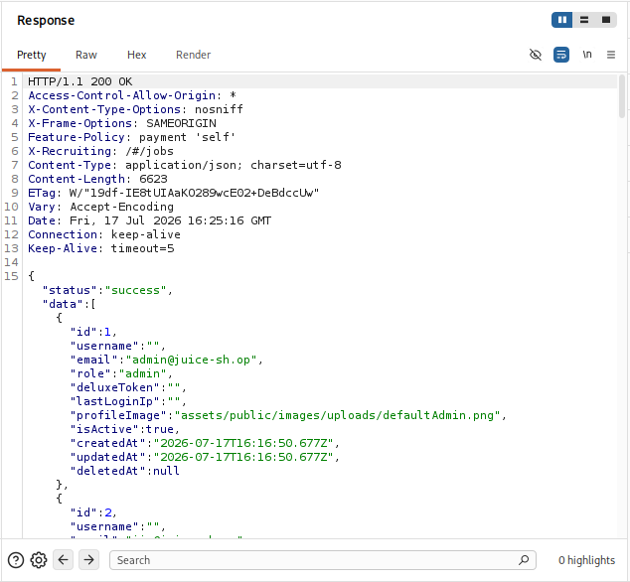
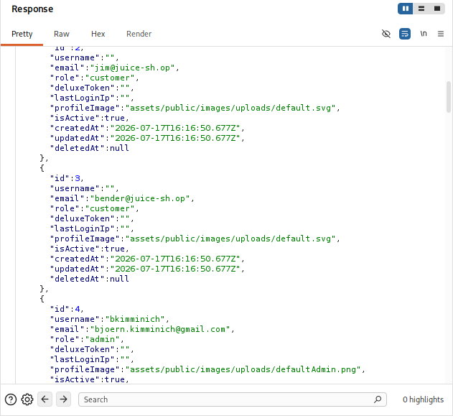
The server returned:
- User IDs
- Email addresses
- Roles
- Profile image paths
- Account status
- Account creation dates

Impact
- Enumerate every registered user with any authenticated account
- Support user profiling and targeted phishing
- Support password spraying
- Support privilege mapping and further attack planning

Recommendation
- Return only information belonging to the authenticated user unless administrative privileges have been verified
- Implement server-side authorization checks before returning user information
- Apply the Principle of Least Privilege

Finding 2 – Insecure Direct Object Reference (IDOR)
Severity: High
CVSS v3.1: 7.5 (High)
OWASP Top 10: A01:2021 – Broken Access Control
CWE: CWE-639 – Authorization Bypass Through User-Controlled Key

Description
Testing individual object references demonstrated that user records could be accessed directly by modifying the identifier in the request. GET /api/Users/1 and GET /api/Users/2 both returned information belonging to other users.

Affected Component / Endpoint
GET /api/Users/{id}

Evidence
Figure 2 — GET /api/Users/1 request
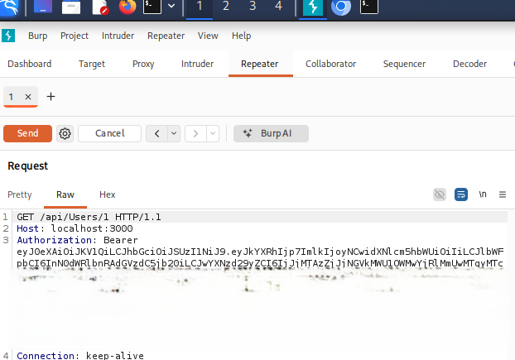
Figure 2 — Response exposing administrator information
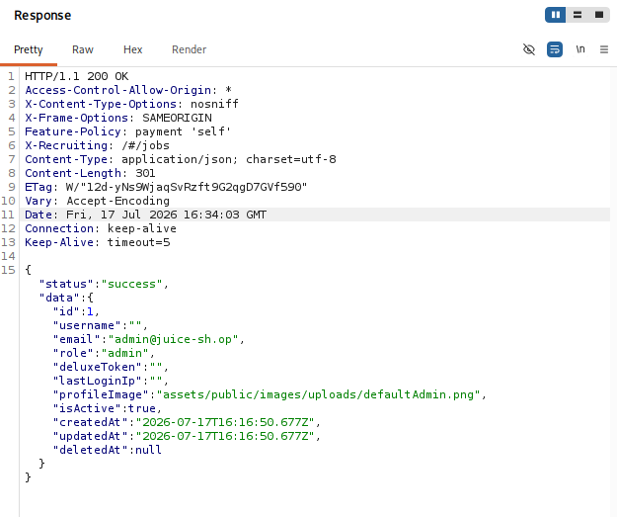
Figure 3 — GET /api/Users/2 request
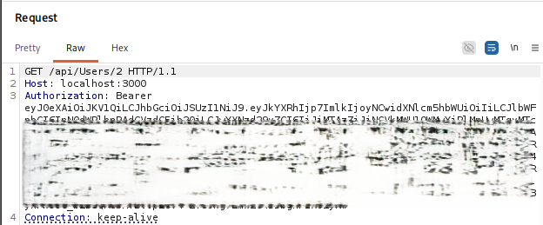
Figure 3 — Response exposing customer information
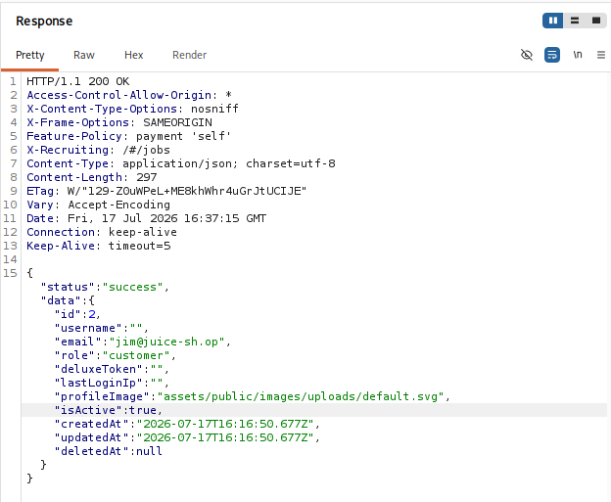

Impact
- Retrieve information belonging to arbitrary users by modifying object identifiers
- Account enumeration
- Administrative account discovery
- Information disclosure supporting targeted attacks

Recommendation
- Verify that the authenticated user is authorized to access the requested resource before returning any data
- Enforce object ownership validation on every request

Finding 3 – Unauthorized Basket Modification
Severity: High
CVSS v3.1: 8.1 (High)
OWASP Top 10: A01:2021 – Broken Access Control
CWE: CWE-639 – Authorization Bypass Through User-Controlled Key

Description
Testing revealed that an authenticated user was able to modify basket items belonging to another user by directly referencing the BasketItem ID. The application failed to verify whether the authenticated user owned the targeted basket item before processing the request.

Affected Component / Endpoint
PUT /api/BasketItems/{id}

Evidence
Figure 4 — PUT /api/BasketItems/1 request
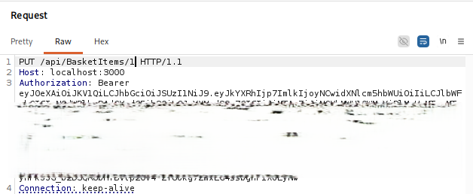
Figure 4 — Response: request accepted, no ownership check enforced
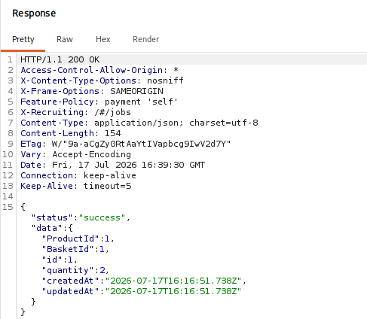

Impact
- Unauthorized modification of another user's shopping basket
- Loss of data integrity
- Alteration of item quantities or another customer's order
- Confirms an IDOR / Broken Access Control vulnerability

Recommendation
- Implement server-side authorization checks to verify ownership of basket items before allowing updates
- Validate resource identifiers against the authenticated user's session on every request

Finding 4 – Unauthorized Basket Deletion (IDOR)
Severity: Critical
CVSS v3.1: 9.1 (Critical)
OWASP Top 10: A01:2021 – Broken Access Control
CWE: CWE-639 – Authorization Bypass Through User-Controlled Key

Description
During authorization testing, the application failed to verify ownership before deleting basket items. By modifying the basket item identifier, an authenticated customer successfully deleted another user's basket item, confirming a Broken Object Level Authorization (BOLA/IDOR) vulnerability due to missing server-side authorization checks.

Affected Component / Endpoint
DELETE /api/BasketItems/{id}

Evidence
Figure 5 — DELETE /api/BasketItems/1 request
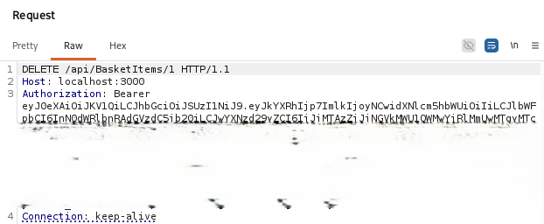
Figure 5 — Response: HTTP/1.1 200 OK, item deleted
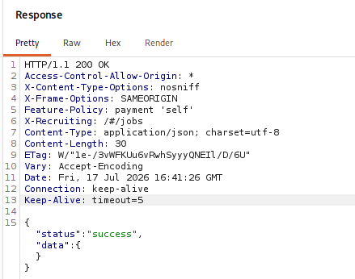

Impact
- Delete another customer's basket items
- Disrupt purchases and manipulate shopping carts
- Affect business operations and data integrity

Recommendation
- Validate ownership before deletion
- Return 403 Forbidden for unauthorized delete requests

Finding 5 – Information Disclosure via API
Severity: High
CVSS v3.1: 7.5 (High)
OWASP Top 10: A01:2021 – Broken Access Control
CWE: CWE-200 – Exposure of Sensitive Information

Description
Testing showed that authenticated users could retrieve information belonging to arbitrary users by directly requesting user identifiers and other API resources without proper authorization checks.

Affected Component / Endpoint
GET /api/Users · GET /api/Feedbacks · GET /api/BasketItems

Evidence
Figure 6 — GET /api/Users request
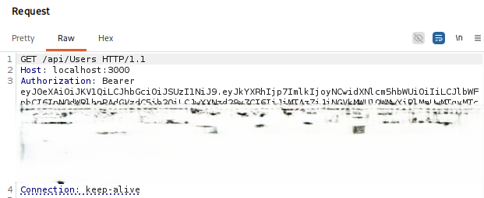
Figure 6 — Response exposing user IDs, emails, and roles


Figure 7 — GET /api/Feedbacks request
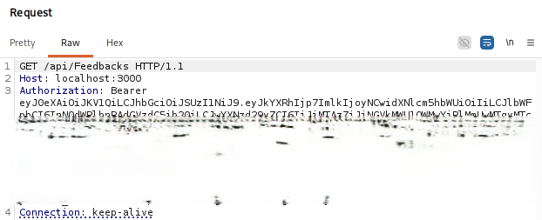
Figure 7 — Response exposing customer feedback records
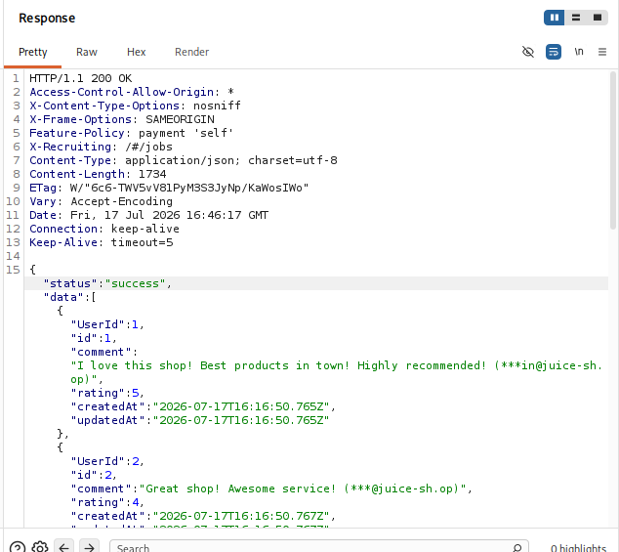
Figure 8 — GET /api/BasketItems request
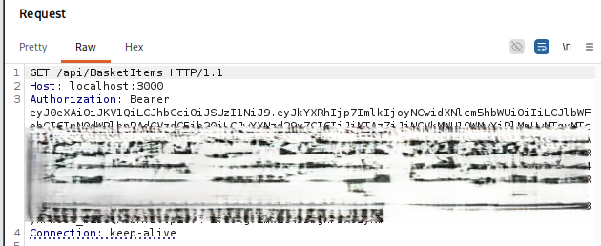
Figure 8 — Response exposing basket data belonging to multiple users
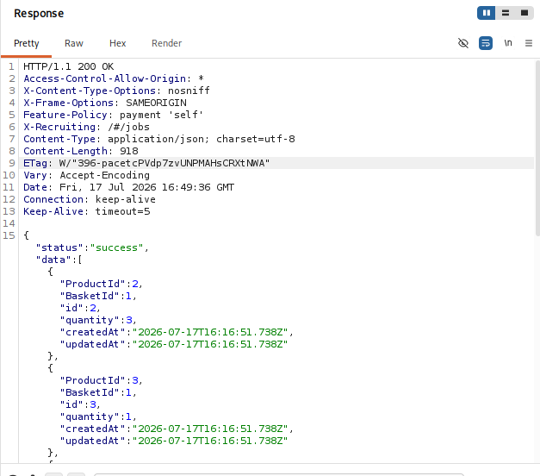

Impact
- User enumeration
- Disclosure of administrator accounts
- Email address exposure
- Information gathering to support future attacks

Recommendation
- Return only information the authenticated user is authorized to access
- Enforce server-side authorization checks on all API endpoints

Finding 6 – Administrative Interface Discovery
Severity: Medium
CVSS v3.1: 5.3 (Medium)
OWASP Top 10: A05:2021 – Security Misconfiguration
CWE: CWE-200 – Exposure of Sensitive Information to an Unauthorized Actor

Description
Manual enumeration identified the administrative interface at http://localhost:3000/#/administration. Testing confirmed the interface exists and is protected by server-side authorization: customer accounts received a 403 Forbidden response, while access was only possible after successful administrator authentication.

Affected Component / Endpoint
GET /#/administration

Evidence
Figure 9 — Administration interface, accessed as an authenticated administrator
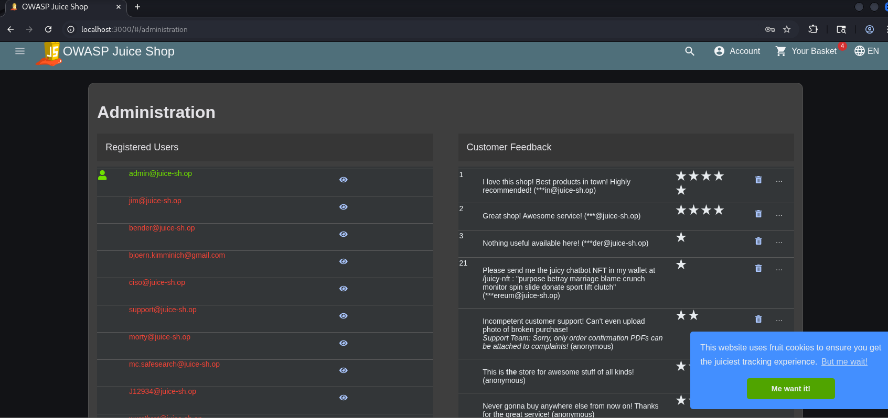
Figure 10 — Customer account receiving 403 Forbidden when attempting the same page
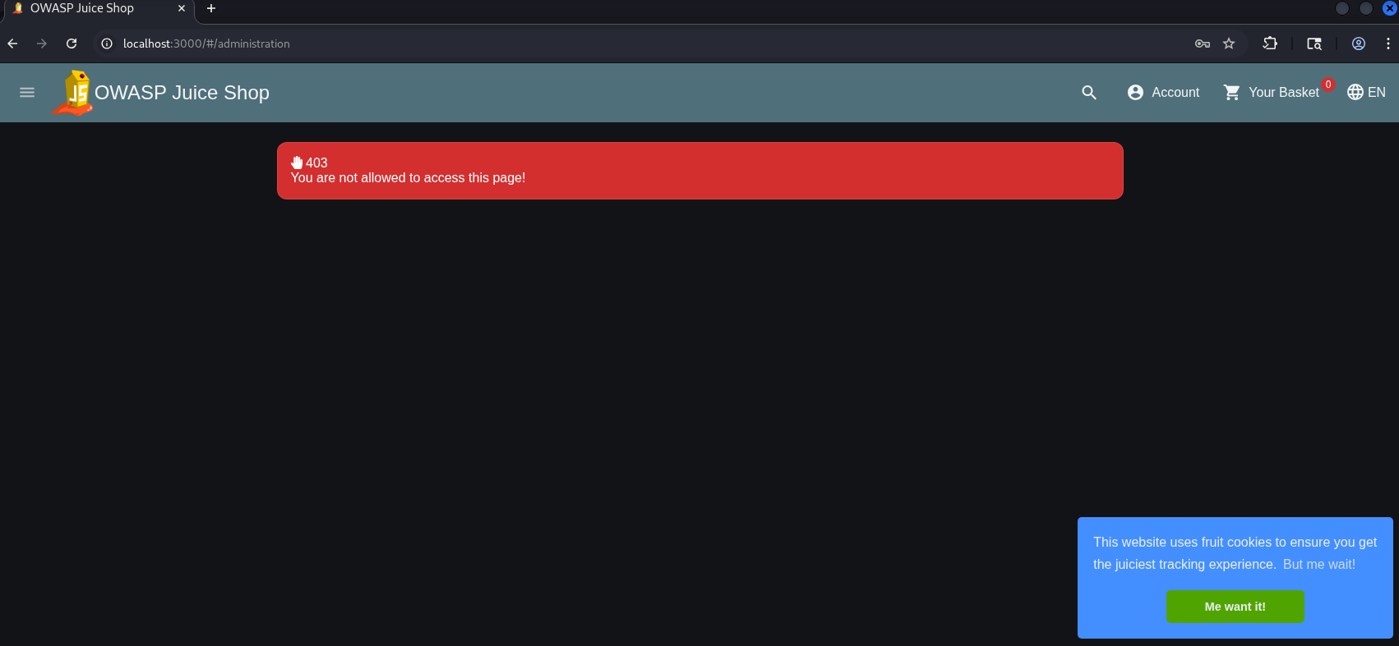

Impact
- Reveals administrative functionality to unauthenticated reconnaissance
- Assists attacker reconnaissance
- Helps identify privileged endpoints for further targeting

Recommendation
- Maintain server-side authorization checks on this route
- Monitor and alert on repeated access attempts against administrative endpoints

Finding 7 – Authentication & JWT Assessment
Severity: Informational
CVSS v3.1: N/A — informational / positive-control finding
OWASP Top 10: A07:2021 – Identification and Authentication Failures

Description
Authentication testing assessed how the application validates JSON Web Tokens (JWTs) before granting access to protected resources. This is a positive-control verification finding rather than a confirmed vulnerability.

Affected Component / Endpoint
POST /rest/user/login · Bearer token validation on protected endpoints

Evidence
Figure 11 — POST /rest/user/login request
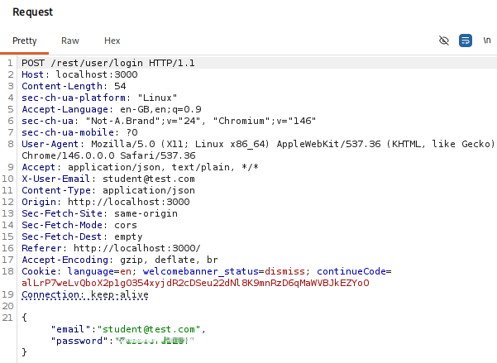
Figure 12 — Successful login response returning a JWT
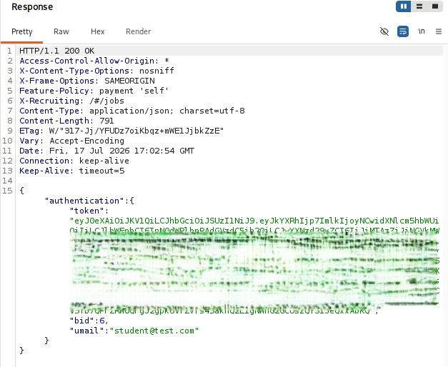
Figure 13 — Authenticated request using Authorization: Bearer <JWT>
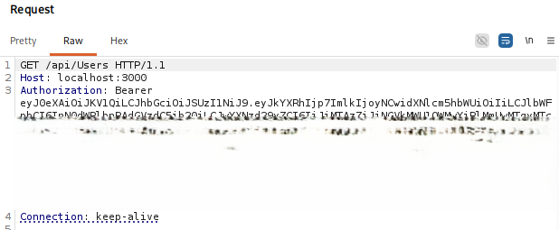
Figure 13 — Successful access to the protected endpoint
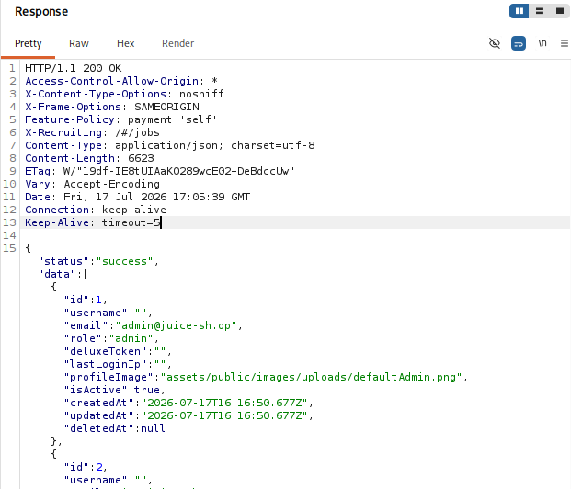
Figure 14 — Request with an invalid/malformed JWT
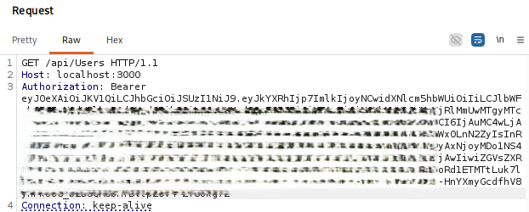
Figure 14 — Resulting 401 Unauthorized response
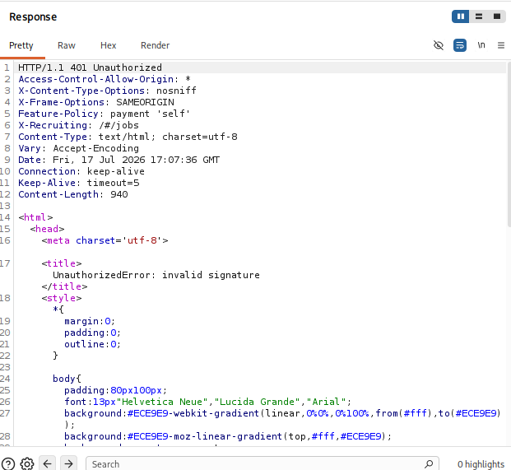

Impact
- Protected endpoints correctly require authentication before access is granted
- Requests without a valid JWT are blocked, confirming this control is effective

Recommendation
- Continue enforcing JWT-based authentication for protected resources
- Validate Authorization headers strictly and reject malformed or invalid tokens
- Implement token expiration, secure storage, and periodic key rotation

Finding 8 – SQL Injection Authentication Bypass
Severity: Critical
CVSS v3.1: 9.8 (Critical)
OWASP Top 10: A03:2021 – Injection
CWE: CWE-89 – SQL Injection

Description
The login functionality was vulnerable to SQL Injection. By injecting SQL syntax into the login fields, authentication was bypassed, allowing successful login as the administrator without valid credentials.

Affected Component / Endpoint
POST /rest/user/login

Payload
' OR 1=1--

Evidence
Figure 15 — SQL Injection payload in the login request
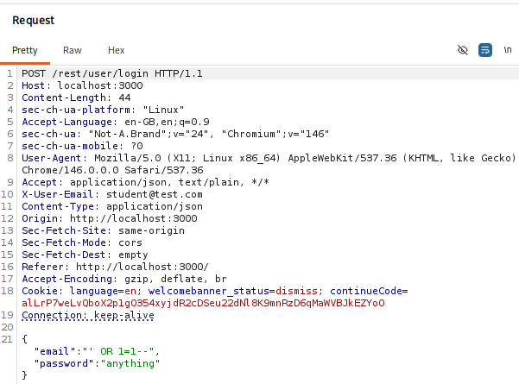
Figure 15 — Login response returning an administrator JWT
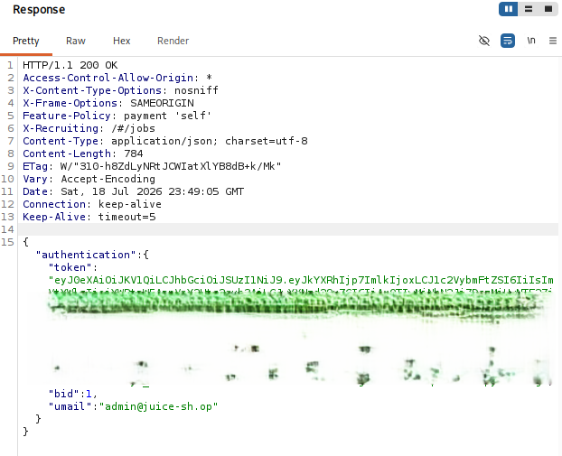
Figure 15 — Browser access to the administration interface after authenticating with the payload


Impact
- Full authentication bypass
- Unauthorized administrator access
- Access to privileged administrative functions
- Potential compromise of application confidentiality and integrity

Recommendation
- Use parameterized queries (prepared statements)
- Validate and sanitize all user input
- Avoid dynamic SQL query construction
- Apply least-privilege permissions to the database account

Finding 9 – Stored Cross-Site Scripting (Stored XSS)
Severity: High
CVSS v3.1: 8.8 (High)
OWASP Top 10: A03:2021 – Injection
CWE: CWE-79 – Improper Neutralization of Input During Web Page Generation ('Cross-site Scripting')

Description
The application was vulnerable to Stored Cross-Site Scripting. User-supplied input was stored and later rendered without proper sanitization, allowing arbitrary JavaScript to execute in the browser of any user who viewed the stored content.

Affected Component / Endpoint
Application input field that stores user-generated content (search / feedback)

Payload
<img src=x onerror=alert(1)>

Evidence
Figure 16 — Payload submitted via the search field
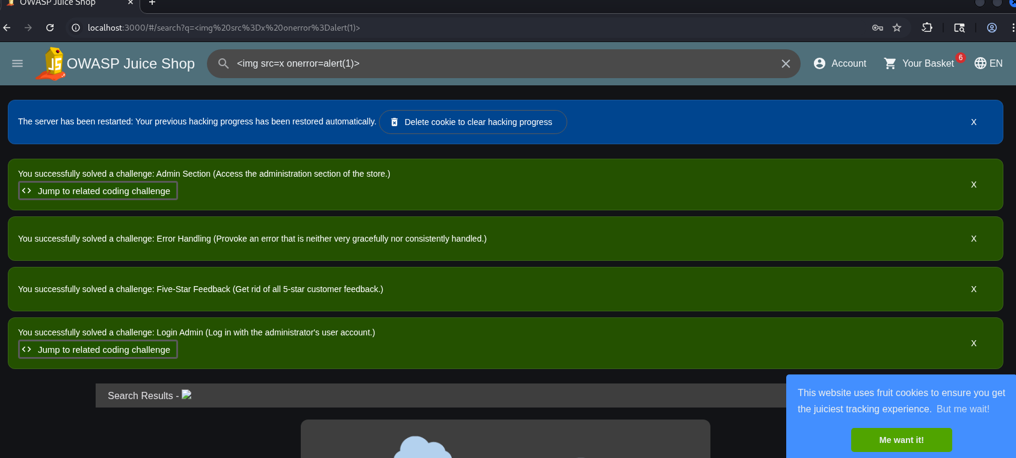
Figure 16 — Resulting JavaScript alert, confirming execution
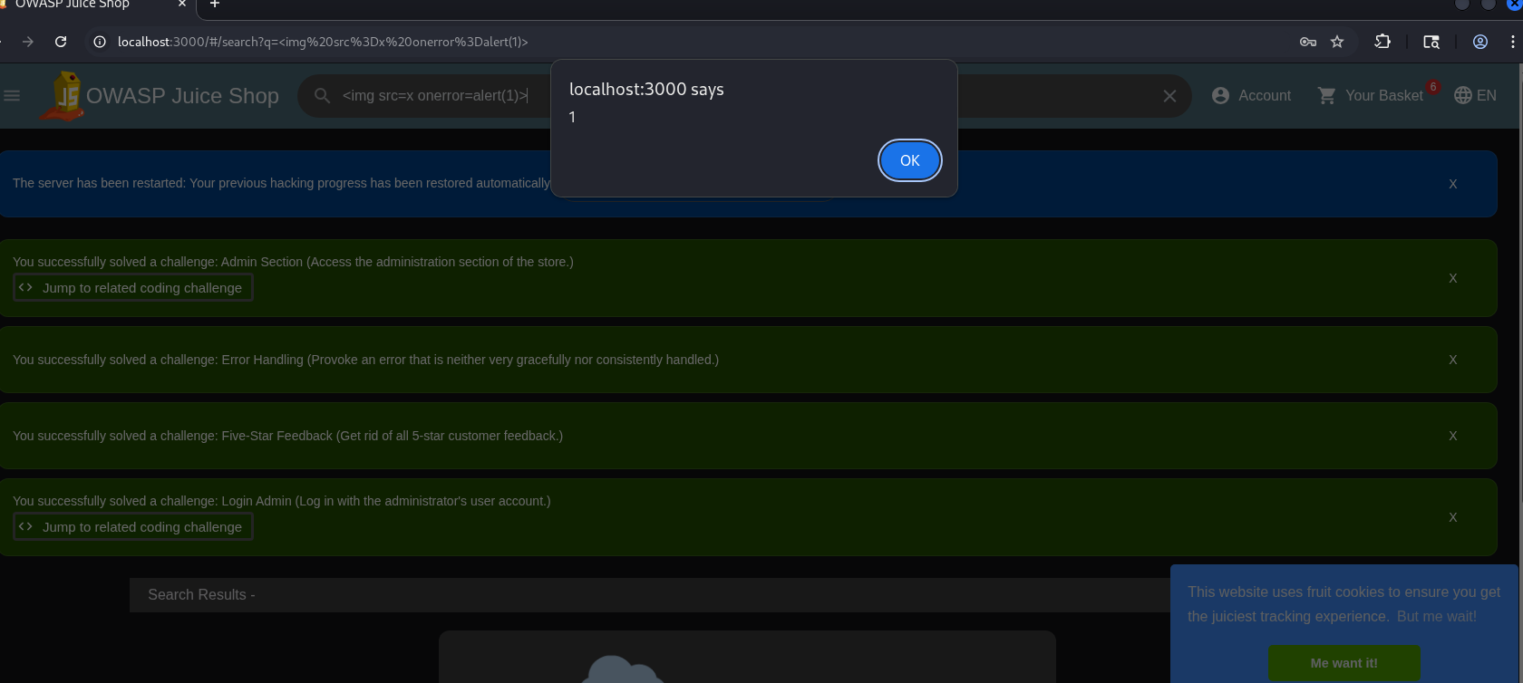

Impact
- Execution of arbitrary JavaScript in a victim's browser
- Session hijacking and cookie theft
- User impersonation and phishing attacks
- Defacement of application content

Recommendation
- Validate and sanitize all user input
- Encode output before rendering in the browser
- Implement a strong Content Security Policy (CSP)
- Use secure frameworks that automatically escape HTML output

6. Validation / Retest Summary
The following tests were performed to validate each finding and confirm expected behavior of existing controls.
Test | Result
Retrieve all users (GET /api/Users) | Failed — Broken Access Control (Finding 1)
Retrieve individual users (GET /api/Users/{id}) | Failed — IDOR (Finding 2)
Modify basket items (PUT /api/BasketItems/{id}) | Failed — Unauthorized Basket Modification (Finding 3)
Delete basket items (DELETE /api/BasketItems/{id}) | Failed — Unauthorized Basket Deletion (Finding 4)
Access administration page as customer | Passed — 403 Forbidden correctly enforced (Finding 6)
Invalid / malformed JWT handling | Passed — 401 Unauthorized correctly enforced (Finding 7)
SQL Injection authentication bypass | Failed — Administrator access obtained (Finding 8)
Stored Cross-Site Scripting (XSS) | Failed — Payload executed successfully (Finding 9)

Overall Impact
The assessment identified multiple High and Critical vulnerabilities, including SQL Injection, Broken Access Control, Insecure Direct Object References (IDOR), Information Disclosure, and Stored Cross-Site Scripting (XSS). While authentication controls correctly rejected malformed and invalid JWTs, inconsistent authorization controls and input validation weaknesses significantly increased the application's attack surface.

7. Risk Summary
The table below summarizes all confirmed findings identified during the assessment. Severity ratings shown here match the CVSS-based ratings given in each finding in Section 5.
Finding | OWASP Category | Severity | Status
Broken Access Control – User Enumeration | A01:2021 | High | Confirmed
Insecure Direct Object Reference (IDOR) | A01:2021 | High | Confirmed
Unauthorized Basket Modification | A01:2021 | High | Confirmed
Unauthorized Basket Deletion | A01:2021 | Critical | Confirmed
Information Disclosure via API | A01:2021 | High | Confirmed
Administrative Interface Discovery | A05:2021 | Medium | Observed
Authentication & JWT Assessment | A07:2021 | Informational | Verified
SQL Injection Authentication Bypass | A03:2021 | Critical | Confirmed
Stored Cross-Site Scripting (XSS) | A03:2021 | High | Confirmed

8. Recommendations
The following remediation measures are recommended to strengthen the application's security posture.

8.1 Prevent SQL Injection
Use parameterized queries (prepared statements) for all database interactions. Avoid constructing SQL statements using user-controlled input. Apply server-side input validation and least-privilege database permissions.
Addresses Findings:
Finding 8 – SQL Injection Authentication Bypass

8.2 Prevent Cross-Site Scripting (XSS)
Validate and sanitize all user input before storage. Encode all output before rendering it within HTML. Deploy a Content Security Policy (CSP) to reduce the impact of injected scripts.
Addresses Findings:
Finding 9 – Stored Cross-Site Scripting

8.3 Enforce Authorization
Apply server-side authorization checks on every API endpoint. Object ownership should be validated before read, update, or delete operations.
Addresses Findings:
Finding 1
Finding 2
Finding 3
Finding 4

8.4 Prevent Information Disclosure
API responses should expose only the minimum information required. Avoid returning internal user IDs, administrative roles, email addresses, or sensitive account metadata unless explicitly required and authorized.

Restrict API responses to the minimum information required by clients. Avoid returning internal user IDs, Administrative roles, internal identifiers, and sensitive metadata - should never be exposed to standard users.
Addresses Findings
Finding 5

8.5 Improve Monitoring
- Enable centralized logging for:
- failed authentication
- authorization failures
- suspicious API enumeration
- privilege escalation attempts
- unauthorized resource access
- excessive API requests, and suspicious object enumeration
Regular log reviews can help detect malicious activity early.

8.6 Conduct Regular Security Testing
Perform periodic penetration testing, secure code reviews, vulnerability assessments, and API security testing. Integrate security testing into the Software Development Lifecycle (SDLC). Implement parameterized queries (prepared statements) to prevent SQL Injection, and validate, sanitize, and properly encode user input to mitigate Cross-Site Scripting (XSS).

9. Conclusion
A penetration test was conducted against the OWASP Juice Shop application using a structured methodology based on the Penetration Testing Execution Standard (PTES). The assessment included reconnaissance, enumeration, authentication testing, authorization testing, vulnerability validation, and manual verification of identified issues.
The testing confirmed multiple authorization weaknesses, including Broken Access Control and Insecure Direct Object References (IDOR), allowing authenticated users to access or manipulate resources beyond their intended permissions. Information disclosure issues were also identified through API endpoints that exposed user details without adequate authorization checks.
Authentication mechanisms demonstrated positive behavior by rejecting malformed and invalid JWTs and enforcing Bearer token formatting. Additionally, administrative functionality correctly denied access to unauthorized users, indicating that some security controls were effectively implemented.
Overall, the assessment identified multiple high-impact vulnerabilities affecting authentication, authorization, and input validation. The combination of SQL Injection, Stored Cross-Site Scripting, Broken Access Control, and Information Disclosure significantly increases the application's overall risk and demonstrates weaknesses across several security domains. Addressing the identified findings through robust server-side authorization checks, role-based access control, and least-privilege principles would significantly improve the application's security posture.
The successful exploitation of SQL Injection and Stored Cross-Site Scripting demonstrates that the application remains vulnerable to common but high-impact web application attacks. These issues, combined with authorization weaknesses, significantly increase the overall risk to the application.

10. References

OWASP Top 10:2021

OWASP Web Security Testing Guide (WSTG)

OWASP Juice Shop Documentation

MITRE CWE

CVSS v3.1 Specification

PTES (Penetration Testing Execution Standard)

11. Appendices

Appendix A – Testing Methodology
1. Reconnaissance
2. Enumeration
3. Vulnerability Assessment
4. Authentication Testing
5. Authorization Testing
6. Exploitation
7. Post-Exploitation Validation
8. Reporting

Appendix B – Tools Used
Tool | Purpose
Burp Suite Community | HTTP interception and request manipulation
Firefox | Manual application testing
Nmap | Network reconnaissance
Gobuster | Directory and content enumeration
Nikto | Web server assessment
Browser Developer Tools | Client-side analysis
JWT Decoder | Token inspection
Burp Intruder | Automated payload testing
Linux Terminal | Manual API testing
Burp Repeater | Manual request manipulation

Appendix C – Evidence Index
All proof-of-concept evidence (Burp Suite requests/responses and browser screenshots) is embedded directly with its corresponding finding in Section 5. This index cross-references each figure for quick lookup rather than repeating the images.
Figure | Description | Finding
Figure 1 | GET /api/Users request and response exposing registered users | Finding 1
Figure 2 | GET /api/Users/1 request and response exposing administrator information | Finding 2
Figure 3 | GET /api/Users/2 request and response exposing customer information | Finding 2
Figure 4 | PUT /api/BasketItems/1 request demonstrating unauthorized basket modification | Finding 3
Figure 5 | DELETE /api/BasketItems/1 request demonstrating unauthorized basket deletion | Finding 4
Figure 6 | GET /api/Users response showing exposed user information | Finding 5
Figure 7 | GET /api/Feedbacks response showing customer feedback records | Finding 5
Figure 8 | GET /api/BasketItems response showing basket information belonging to multiple users | Finding 5
Figure 9 | Administration interface accessed by an administrator | Finding 6
Figure 10 | 403 Forbidden response for a customer account | Finding 6
Figure 11 | POST /rest/user/login request | Finding 7
Figure 12 | Successful login response containing the JWT | Finding 7
Figure 13 | Authenticated request using Authorization: Bearer <JWT> | Finding 7
Figure 14 | Request without a valid JWT resulting in 401 Unauthorized | Finding 7
Figure 15 | SQL Injection login payload and successful administrator login | Finding 8
Figure 16 | Stored XSS payload and resulting JavaScript alert | Finding 9

Assessment Limitations

The assessment was conducted against a local deployment of OWASP Juice Shop within a controlled laboratory environment. Testing was limited to the application functionality available during the assessment and did not include source code review, infrastructure testing, denial-of-service testing, or third-party integrations. Results should therefore be interpreted within the scope of the defined testing environment.

